Phase -1:

Problem Identification
- What specific campus-life problem are you solving?
After entering university life, most students lack clarity about how to build a strong resume, prepare for interviews, secure internships, and understand current industry requirements. They are unaware of what skills are in demand, how career paths work, and what steps they should take each semester to move closer to their career goals. This lack of structured guidance leads to confusion and poor career planning.
- Who is most affected by this problem?
The problem primarily affects undergraduate students, especially those in their early academic years.
- How often does this problem occur?
This problem occurs continuously, especially for students from the 1st to 4th semester. During this period, students are uncertain about choosing domains, building skills, applying for internships, and preparing for placements, making it a recurring and long-term issue.
- How is this problem currently addressed, and why is the current solution inadequate?
Currently, students rely on platforms like LinkedIn, YouTube, and random online resources. While LinkedIn provides access to professionals, it lacks a focused campus-based community and structured guidance. Information is scattered, unverified, and overwhelming, making it difficult for students to follow a clear and personalized career path.

Impact & Relevance
- What negative impact does this problem have on students?
- Slow personal and professional growth
- Low exposure to real-world industry practices
- Confusion in choosing career paths
- Poor resume quality and interview preparation
- Low confidence and motivation
- Missed internship and job opportunities

- How many students are likely affected by this problem?
Approximately 90% of students from 1st to 4th semester are affected, as most of them are still exploring career options and lack proper mentorship and guidance.
Solution Concept
- Briefly describe your proposed solution.
The proposed solution is a centralized career guidance and industry-connect platform designed specifically for students. It provides structured, personalized, and community-driven support to help students prepare for internships and jobs.
Key features include:
- Opinion on resume( reviews)
- Career counselling according to your interests and goals
- Connect with industry experts /Alumni
- Departments & channels based on your fields
- Internship opportunities
- Interviews related information and guidance (mock interviews, interview question bank where the most asked question are shared)

- How does your solution improve the daily campus experience?
The platform helps students feel confident that they are moving in the right direction by offering a pre-defined career pathway. It reduces confusion, increases motivation, and builds a positive mindset. Students experience higher self-satisfaction, better planning, and stronger preparation for their future careers.
Users & Validation
- Who is your primary user, and how will you validate that they need your solution?
Primary Users:
- Students (currently enrolled especially 1st – 4th semester)
- Alumni and industry professionals( affiliated with UCP)
Validation Methods:
To validate the problem, informal interviews and discussions were conducted with students across different semesters. Around 4 out of 5 students shared that they had faced similar challenges during their academic journey, such as lack of career clarity, resume-building difficulties, limited internship guidance, and insufficient exposure to industry expectations.
Most of these students also mentioned that if a dedicated platform for career guidance, resume review, internships, and alumni interaction had existed, it would have been extremely helpful in guiding them in the right direction and reducing confusion about their future career paths.
Responses:
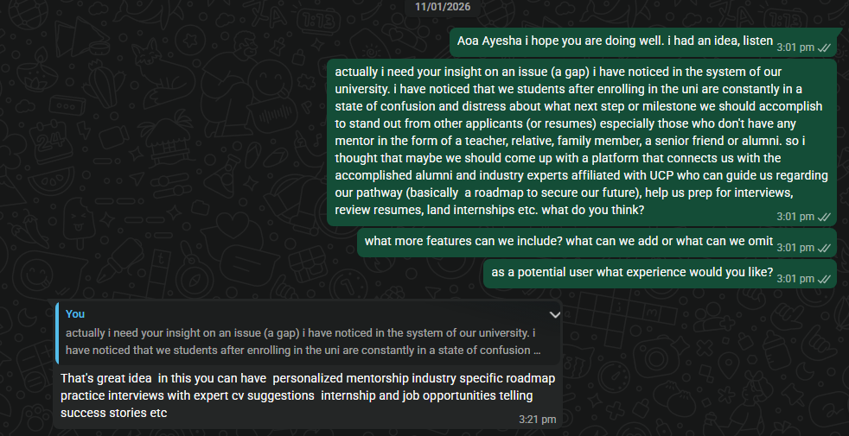
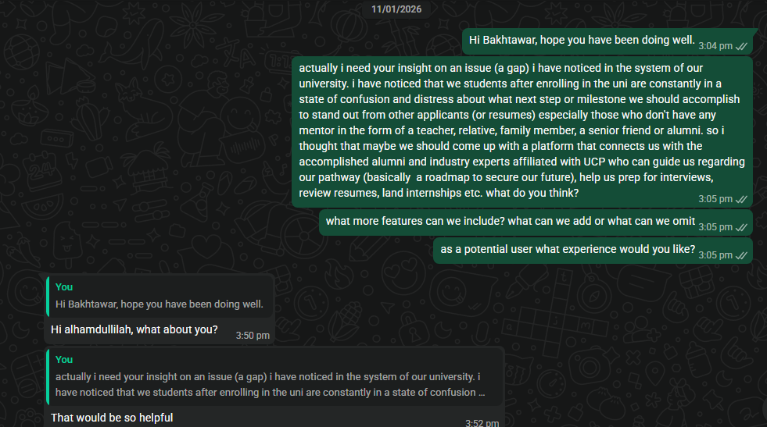
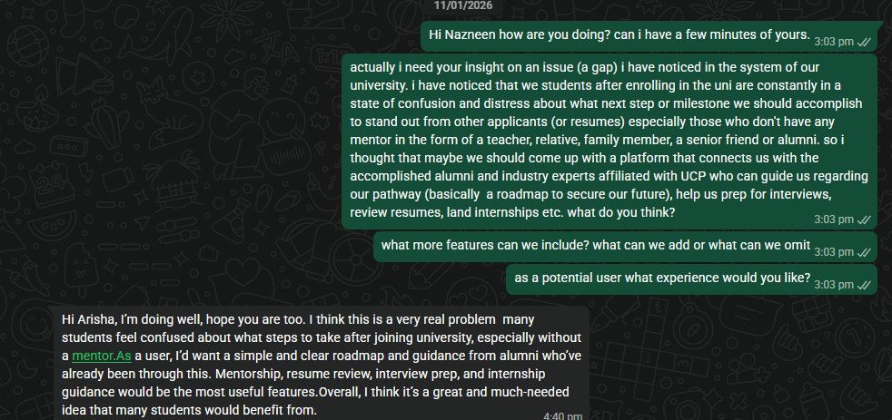

Phase-2:

User Research & Validation
- What did you learn from talking to users?
From conversations with potential users, it became clear that the core problem is not a lack of talent or effort among students, but a lack of direction, clarity, and structured guidance. Many students expressed that they are unsure about which skills to learn, how to align their projects with career goals, and what recruiters actually expect for different roles.
They suggested features such as a discussion-based system (similar to Reddit) where students can ask questions and receive answers based on real experiences.
Additionally, students emphasized the emotional aspect of the problem wanting to feel supported, motivated, and not alone during their academic journey, with access to guidance whenever they feel stuck or confused.
- How did user feedback change your solution design?
Users feedback influenced us to avoid feature overload and focus on simplicity and clarity instead, ensuring that the students feel guided step by step rather than overwhelmed.
- Which assumptions on your understanding of the problem were validated or disproved?
Validated assumptions:
- Almost all students faced the same confusion regarding future career paths, skill sets they need to acquire, and what the industry expects from them.
- Students agree that they value the insights and knowledge given by Alumni and experienced Industry experts more than the generic outline found online.
Disproved or refined assumptions:
Users want a focused, simple and practical platform over a complex system that is loaded with a lot of features. And so removed any feature that we assumed would be an extra or unnecessary one (e.g. a separate channel/ section for interview talks and guidance, integration from other apps and websites, Ai resume builder).
MVP Scope & Features
- What core features will be included in the MVP?
The MVP will include the following core features, focused on solving the most critical student problems:
- Custom Roadmap Generator
Students receive a personalized, step-by-step roadmap based on their interests, current skills, academic semester, and career goals. This roadmap clearly outlines what skills to learn, what projects to build, and which opportunities to target.
- Post Queries & Project Reviews
Students can post questions, project ideas, or completed projects and receive reviews, suggestions, and opinions from seniors, alumni, and industry experts. This enables experience-based learning and real-world guidance.
- Skill-Based Internship Notifications
The platform notifies students about internship opportunities that match their existing abilities and skill sets, helping them apply to relevant roles instead of random openings.
- Opportunity Board
A centralized board listing internships, hackathons, workshops, and other career-building opportunities, filtered by domain and skill level.
- Which features are out of scope for this hackathon?
The following features are out of scope:
- Live 1-on-1 mentoring or video calls
- AI-driven resume scoring and advanced analytics
- Mock interviews with real-time evaluation
- Full alumni verification and rating system
- Paid subscriptions or monetization features
These features can be explored in future iterations after validating user demand.
- How will your MVP demonstrate value to users?
This MVP delivers clarity to the students. It helps students gain understanding about their career direction through personalized roadmaps, receive real feedbacks and opinions regarding projects and ideas from experienced seniors/Alumni, discover opportunities that actually match their skills and stay informed about relevant internships and events in one place. It basically reduce confusion, increase confidence level and gives a clear pathway towards your goal.

On the other hand, Mentors from industry can identify motivated and skilled students early through their projects and discussions, creating opportunities for internships, referrals, or team hiring. Mentors will gain professional recognition by university.

Implementation & Technical Planning
- Which technical tools, platforms, or languages will you use?
Since our team does not have any experience building apps from scratch, the MVP will be built using no-code/low-code platforms:
- Loveable – For building the main app interface, user flows, and database interactions without coding.
- VO (Voice/Virtual Orchestration tool) – To implement interactive features such as notifications, reminders, and guided workflows.
- Integrated Database – Loveable’s built-in database or a simple external database (like Airtable) to store user profiles, posts, roadmaps, and opportunities.
This approach allows rapid development, functional prototypes, and real-time testing without needing advanced coding skills.

2. How will you prioritize features for Day 2 development?
Our MVP will follow the following feature prioritization:
- User authentication and basic profile setup
- Custom roadmap generator (core differentiating feature)
- Post and reply system for queries and project reviews
- Opportunity Board with basic filtering
- Skill-based internship notification logic
- UI polish and basic notifications
This ensures the core user journey works end-to-end early, with enhancements added later.

- What challenges do you anticipate, and how will you address them?
Anticipated Challenges & Solutions:
- Time constraints:
We will focus strictly on core features and avoid over engineering.
- Quality of guidance in early stages:
Will be using curated sample roadmaps and demo mentor responses for initial validation.
- Matching internships to skills:
We will start with simple keyword and rule-based matching instead of complex ML models.
- User engagement during demo:
Will design a clean, intuitive UI and demonstrate real user flows rather than isolated features.
- Scalability concerns:
We will use modular APIs and a flexible database structure to allow future growth.

Phase – 3:
Problem Statement
Students and fresh graduates struggle to find relevant, experienced mentors in their field, while industry professionals want to give back but lack efficient ways to connect with suitable mentees.
Our Solution
We built an AI-powered matchmaking platform that intelligently connects students with alumni mentors based on skills, goals, and availability, featuring profile matching, scheduling, and direct communication tools.
https://id-preview--35d40b51-6e2c-4144-a74c-d110a3e26edf.lovable.app/

